**IDEATION PHASE**

**Define the Problem Statements**

|  |  |
| --- | --- |
| Date | 01 November 2022 |
| Team ID | PNT2022TMID40047 |
| Project Name | Smart waste management System for Metropolitan cities |
| Maximum Marks | 2 Marks |

**Problem Statements:**

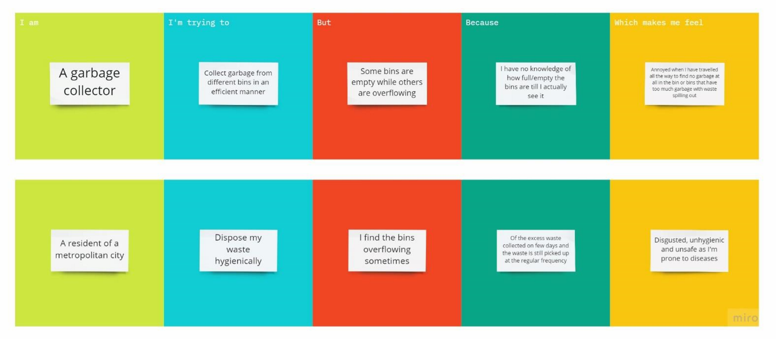

|  |  |  |  |  |  |
| --- | --- | --- | --- | --- | --- |
| **Problem**  **Statement (PS)** | **I am** | **I’ m trying to** | **But** | **Because** | **Which makes me**  **feel** |
| PS-1 | A garbage collector | Collect garbage from different bins in an efficient manner | Some bins are empty while others are overflowing | I have no knowledge of  how  full/empty the bins are till I see it | Annoyed when I have travelled all the way to find no garbage at all in the bin or bins that  have too much garbage with waste spilling out |
| PS-2 | A resident of a  metropolitan  city | Dispose my waste hygienically | I find the bins overflowing sometimes | Of the excess waste collected on few days and the waste is still picked up at the regular frequency | Disgusted, unhygienic and unsafe as I am prone to diseases |